Supplementary Table S1. Data matrix used for the morphology-based phylogenetic analysis. Inapplicable characters coded as (-), missing characters as (?).
 | 0  1 | 0 2 | 0 3 | 0 4 | 0 5 | 0 6 | 0 7 | 0 8 | 0 9 | 1 0 | 1 1 | 1 2 | 1 3 | 1 4 | 1 5 | 1 6 | 1 7 | 1 8 | 1 9 | 2 0 | 2 1 | 2 2 | 2 3 | 2 4 | 2 5 | 2 6 | 2 7 | 2 8 | 2 9 | 3 0 | 3 1 | 3 2 | 3 3 | 3 4 | 3 5
Cercyon lateralis | 0 | 0 | 0 | 1 | 1 | 1 | 1 | 0 | 0 | 1 | 0 | 0 | 0 | 0 | 0 | 0 | 0 | 0 | 0 | 1 | 0 | - | 2 | 0 | 0 | 0 | 0 | - | 1 | 1 | 1 | 1 | 0 | 0 | 0
Cetiocyon incantatus | 0 | 1 | 0 | 1 | 0 | 0 | - | - | 0 | 0 | 0 | 0 | 0 | 0 | 0 | 0 | 0 | 0 | 0 | 0 | 0 | 1 | 1 | 0 | 0 | 0 | 0 | - | 0 | - | 1 | 1 | 0 | 0 | 0
Cetiocyon goliathus | 1 | 1 | 1 | 0 | 1 | 0 | - | - | 1 | 1 | 1 | 0 | 0 | 0 | 0 | 0 | ? | ? | ? | 1 | 1 | ? | ? | ? | ? | ? | ? | ? | ? | ? | ? | ? | ? | ? | ?
Cetiocyon traipela | 0 | 1 | 2 | 0 | 1 | 0 | - | - | 0 | 1 | 0 | 0 | 0 | 0 | 0 | 0 | 1 | 1 | 1 | 1 | 1 | 1 | 0 | 0 | 1 | 1 | 1 | 0 | 1 | 1 | 0 | 1 | 1 | 0 | 0
Cetiocyon hanseni | 0 | 1 | 0 | 1 | 1 | 0 | - | - | 0 | 1 | 0 | 0 | 0 | 0 | 0 | 0 | 0 | 0 | 0 | 1 | 1 | 1 | 0 | 0 | 0 | 0 | 0 | - | 0 | - | 0 | 1 | 0 | 0 | 0
Cetiocyon papuensis | 0 | 1 | 0 | 1 | 1 | 0 | - | - | 0 | 1 | 0 | 0 | 0 | 0 | 0 | 0 | 1 | 1 | 0 | 1 | 1 | 1 | 0 | 0 | 1 | 0 | 0 | - | 1 | 1 | 0 | 1 | 1 | 0 | 0
Cetiocyon loksai | 0 | 1 | 1 | 0 | 1 | 0 | - | - | 0 | 1 | 0 | 0 | 0 | 0 | 0 | 0 | 1 | 1 | 0 | 1 | 1 | 1 | 0 | 0 | 1 | 1 | 1 | 0 | 1 | 1 | 0 | 1 | 1 | 0 | 0
Cetiocyon riedeli | 1 | 1 | 1 | 0 | 1 | 0 | - | - | 1 | 1 | 1 | 0 | 0 | 0 | 0 | 0 | 0 | 1 | 1 | 1 | 1 | 1 | 0 | 1 | 1 | 1 | 1 | 1 | 1 | 1 | 0 | 1 | 1 | 0 | 0
Cetiocyon hebaueri | 1 | 1 | 1 | 0 | 1 | 0 | - | - | 1 | 1 | 0 | 0 | 0 | 0 | 0 | 1 | 0 | 1 | 0 | 1 | 1 | 1 | 0 | 1 | 1 | 1 | 1 | 1 | 1 | 1 | 0 | 1 | 1 | 0 | 0
Cetiocyon cribripunctatus | 1 | 1 | 1 | 0 | 1 | 0 | - | - | 1 | 1 | 1 | 0 | 0 | 0 | 0 | 1 | 0 | 1 | 0 | 1 | 1 | 2 | 0 | 1 | 1 | 1 | 1 | 1 | 1 | 1 | 0 | 1 | 1 | 0 | 0
Cetiocyon paweli | 0 | 1 | 0 | 1 | 1 | 0 | - | - | 0 | 1 | 0 | 0 | 0 | 0 | 0 | 0 | 1 | 1 | 0 | 1 | 1 | 2 | 0 | 0 | 0 | 0 | 0 | - | 1 | 1 | 1 | 0 | 1 | 0 | 0
Cetiocyon depilis | 0 | 1 | 0 | 1 | 1 | 0 | - | - | 0 | 1 | 0 | 0 | 0 | 0 | 0 | 0 | 0 | 0 | 0 | 1 | 1 | 2 | 0 | 0 | 1 | 0 | 0 | - | 0 | - | 1 | 0 | 1 | 0 | 0
Cetiocyon onyx | 0 | 1 | 2 | 0 | 1 | 0 | - | - | 0 | 1 | 0 | 0 | 0 | 0 | 0 | 0 | 1 | 1 | 1 | 1 | 1 | 2 | 0 | 0 | 1 | 1 | 1 | 1 | 1 | 1 | 0 | 1 | 1 | 0 | 0
Cetiocyon augai | 1 | 1 | 2 | 0 | 1 | 0 | - | - | 1 | 1 | 1 | 0 | 0 | 0 | 0 | 0 | 0 | 1 | 1 | 1 | 1 | 1 | 0 | 0 | 1 | 1 | 1 | 1 | 1 | 1 | 0 | 1 | 1 | 0 | 0
Cetiocyon ibiscanus | 0 | 1 | 0 | 1 | 1 | 0 | - | - | 0 | 1 | 0 | 0 | 0 | 0 | 0 | 0 | 1 | 1 | 0 | 1 | 1 | 2 | 0 | 0 | 1 | 0 | 0 | - | 0 | - | 0 | 0 | 0 | 0 | 0
Cetiocyon jakli | 1 | 1 | 1 | 0 | 1 | 0 | - | - | 1 | 1 | 1 | 0 | 0 | 0 | 0 | 0 | 1 | 1 | 0 | 1 | 1 | 2 | 0 | 0 | 1 | 1 | 1 | 1 | 1 | 1 | 0 | 1 | 1 | 0 | 0
Cetiocyon mogianus | 0 | 1 | 1 | 0 | 1 | 0 | - | - | 0 | 1 | 0 | 0 | 0 | 0 | 0 | 0 | 1 | 1 | 0 | 1 | 1 | 2 | 0 | 0 | 1 | 1 | 1 | 0 | 1 | 0 | 0 | 1 | 1 | 0 | 0
Cetiocyon gemellus | 1 | 1 | 2 | 0 | 1 | 0 | - | - | 0 | 1 | 0 | 0 | 0 | 0 | 0 | 0 | 1 | 1 | 1 | 1 | 1 | 1 | 0 | 1 | 1 | 1 | 0 | - | 1 | 1 | 0 | 1 | 0 | 0 | 0
Cetiocyon colossus | 1 | 1 | 1 | 0 | 1 | 0 | - | - | 0 | 1 | 0 | 0 | 0 | 0 | 0 | 0 | 1 | 1 | 1 | 1 | 1 | 1 | 0 | 1 | 1 | 1 | 0 | - | 1 | 1 | 0 | 1 | 0 | 0 | 1
Cetiocyon hamifer | 0 | 1 | 2 | 0 | 1 | 0 | - | - | 0 | 1 | 0 | 0 | 0 | 0 | 0 | 0 | 1 | 1 | 0 | 1 | 1 | 2 | 0 | 0 | 0 | 1 | 1 | 0 | 1 | 0 | 0 | 1 | 1 | 1 | 0
Platycyon wauensis | 0 | 1 | 0 | 1 | 1 | 1 | 1 | 1 | 0 | 1 | 0 | 0 | 0 | 0 | 1 | 0 | 0 | 0 | 0 | 1 | 0 | 2 | 1 | 0 | 1 | 0 | 0 | - | 1 | 1 | 0 | 1 | 0 | 0 | 0
Pelosoma eremita | 0 | 1 | 0 | 1 | 1 | 1 | 1 | 1 | 0 | 1 | 0 | 1 | 0 | 1 | 0 | 0 | 0 | 0 | 0 | 1 | 0 | 1 | 1 | 1 | 1 | 0 | 0 | - | 1 | 1 | 0 | 1 | 0 | 0 | 0
Ercycodes fossus | 0 | 0 | 0 | 0 | 1 | 0 | - | - | 0 | 1 | 0 | 0 | 1 | 1 | 0 | 0 | 0 | 0 | 0 | 1 | 0 | 0 | 0 | 0 | 0 | 0 | 0 | - | 1 | 1 | 1 | 1 | 0 | 0 | 0
Cercyodes kingensis | 0 | 0 | 0 | 0 | 1 | 1 | 0 | 0 | 0 | 1 | 0 | 0 | 1 | 1 | 0 | 0 | 0 | 0 | 0 | 1 | 0 | 2 | 0 | 0 | 0 | 0 | 0 | - | 1 | 1 | 1 | 1 | 0 | 0 | 0
Pseudosternum maculatum | 0 | 1 | 0 | 1 | 1 | 1 | 0 | 0 | 0 | 1 | 0 | 0 | 0 | 0 | 1 | 0 | 0 | 0 | 0 | 1 | 0 | 1 | 1 | 0 | 0 | 0 | 0 | - | 1 | 1 | 1 | 1 | 0 | 0 | 0
Australocyon variegatus | 0 | 0 | 0 | 1 | 1 | 1 | 1 | 0 | 0 | 1 | 0 | 0 | 0 | 0 | 0 | 0 | 0 | 0 | 0 | 1 | 0 | 0 | 1 | 0 | 1 | 0 | 0 | - | 0 | - | 1 | 0 | 0 | 0 | 0
Oosternum simplex | 0 | 0 | 1 | 1 | 1 | 1 | 1 | 0 | 0 | 1 | 0 | 0 | 0 | 0 | 1 | 0 | 0 | 0 | 0 | 1 | 0 | 1 | 0 | 0 | 0 | 0 | 0 | - | 0 | - | 0 | 1 | 0 | 0 | 0

Supplementary Table S2. Altitudinal distribution of Cetiocyon species based on their occurrence data. First 11 columns give number of collecting events / specimens per altitude examined for each species. Events and specimens from the Mt. Wilhelm survey are highlighted in bold. Altitudinal ranges of the species known from the single collecting event. are indicated by an asterisk.
Species | ≤50 | 120 | 200 | 300-400 | 700 | 1100-1200 | 1400-1570 | 1700-1800 | 2200-2300 | 2700 | 2500-2800 | Altitudinal range | Coded for reconstructions as
Cetiocyon hanseni | 7/11 | 12/14 | 4/4 | 3/5 | 3/3  2/3 | 4/111 | (1/1)* |  |  |  |  | 0-1200 | lowland (<1200)
Cetiocyon papuensis | ?/3 |  |  |  | 1/2 |  |  |  |  |  |  | 0-700 | lowland (<1200)
Cetiocyon ibiscanus |  | 1/1 |  |  |  |  |  |  |  |  |  | 120* | lowland (<1200)
Cetiocyon depilis |  |  |  |  |  | 3/3 |  |  |  |  |  | 1200 | ≥1200
Cetiocyon paweli |  |  |  |  |  | 3/3 |  |  |  |  |  | 1200 | ≥1200
Cetiocyon mogianus |  |  |  |  |  | 2/2 |  |  |  |  |  | 1200 | ≥1200
Cetiocyon loksai |  |  |  |  |  | 9/23 | 1/2 | 3/3  2/10 |  |  |  | 1200-1800 | ≥1200
Cetiocyon jakli |  |  |  |  |  |  | 1/3 |  |  |  |  | 1570* | ≥1200
Cetiocyon hamifer |  |  |  |  |  |  | 1/2 |  |  |  |  | 1570* | ≥1200
Cetiocyon colossus |  |  |  |  |  |  | 1/1 |  |  |  |  | 1570* | ≥1200
Cetiocyon traipela |  |  |  |  |  |  | 3/2 | 2/2 |  |  |  | 1400-1800 | ≥1200
Cetiocyon hebaueri |  |  |  |  |  |  |  | 1/2 |  |  |  | 1700-1800* | ≥1700
Cetiocyon onyx |  |  |  |  |  |  |  | 5/5 |  |  |  | 1700 | ≥1700
Cetiocyon gemellus |  |  |  |  |  |  |  | 1/2 |  |  |  | 1700* | ≥1700
Cetiocyon riedeli |  |  |  |  |  |  |  | 5/7 | 2/2 |  |  | 1700-2300 | ≥1700
Cetiocyon augai |  |  |  |  |  |  |  |  | 5/5 |  |  | 2200 | ≥2200
Cetiocyon cribripunctatus |  |  |  |  |  |  |  |  | 1/5 | 23/26 |  | 2300-2700 | ≥2200
Cetiocyon goliathus |  |  |  |  |  |  |  |  |  |  | 1/1 | 2500-2800* | ≥2200

Supplementary Table S3. List of sequenced Cetiocyon specimens from Mt. Wilhelm transect, with indication of succesfully amplified gene fragments and GenBank accession numbers of Jerry-Tom cox1 sequences used for the analyses.

Voucher | Morphological ID | Altitude / Vial # | cox1  (barcoding) | cox1  (sPat-sJerry) | cox1  (Jerry-Tom) | cox1  (Chy-Pat) | GenBank  Accession  (Jerry-Tom)
MF1754 | female | 700 m / 16273
MF1755 | C. papuensis | 700 m / 16083 |  |  | ● |  | MH142717
MF1756 | C. hanseni | 120 m / 3974 |  |  |  | ●
MF1757 | female | 120 m / 22331
MF1758 | C. hanseni | 200 m / 14369 |  |  | ● |  | MH142716
MF1759 | C. cribripunctatus | 2700 m / 6488 |  | ● | ● |  | MH142715
MF1760 | C. augai | 2200 m / 15735 |  |  | ● |  | MH142714
MF1761 | female | 1700 m / 9114 |  | ● | ● |  | MH142713
MF1762 | C. cribripunctatus | 2700 m / 14145 |  | ● | ● |  | MH142712
MF1763 | C. depilis | 1200 m / 17354 |  |  | ● |  | MH142711
MF1764 | female | 1700 m / 5645
MF1765 | C. paweli | 1200 m / 17360 |  |  | ● |  | MH142710
MF1766 | C. hanseni | 700 m / 16019 |  |  | ● |  | MH142709
MF1767 | C. ibiscanus | 700 m / 16236 |  |  | ● |  | MH142708
MF1768 | C. papuensis | 700 m / 16083 |  |  | ● |  | MH142707
MF1769 | C. hanseni | 700 m / 15664 |  |  | ● |  | MH142706
MF1770 | C. hanseni | 120 m / 22265 |  |  | ● |  | MH142705
MF1771 | C. hanseni | 120 m / 16574 |  |  | ● | ● | MH142704
MF1772 | C. hanseni | 120 m / 17649
MF1773 | C. hanseni | 120 m / 17658.1
MF1774 | C. hanseni | 200 m / 9663 |  |  | ● |  | MH142703
MF1775 | C. cribripunctatus | 2700 m / 14109
MF1776 | C. cribripunctatus | 2700 m / 5960 |  |  | ● | ● | MH142702
MF1777 | C. cribripunctatus | 2700 m / 14207 | ●
MF1778 | C. cribripunctatus | 2700 m / 14340 |  |  | ● |  | MH142701
MF1779 | C. augai | 2200 m / 2484
MF1780 | C. riedeli | 1700 m / 5687 |  |  | ● |  | MH142700
MF1781 | C. onyx | 1700 m / 2419
MF1782 | C. onyx | 1700 m / 15384 |  |  | ● |  | MH142699
MF1783 | C. loksai | 1700 m / 5645.1 |  |  | ● |  | MH142698
MF1784 | C. mogianus | 1200 m / 17078
MF1785 | C. depilis | 1200 m / 17020 |  |  | ● |  | MH142697
MF1786 | C. paweli | 1200 m / 17327
MF1787 | C. loksai | 1200 m / 17327 | ●
EAV19 | female | 1700 m / 5672 |  | ● | ● |  | MH142718

Supplementary Table S4. Genetic divergence between sequences (in %) estimated using the maximum composite likelihood model as implemented in MEGA7.

 |  | 1 | 2 | 3 | 4 | 5 | 6 | 7 | 8 | 9 | 10 | 11 | 12 | 13 | 14 | 15 | 16 | 17 | 18 | 19 | 20 | 21
1 | MF1785: C. depilis
2 | MF1763: C. depilis | 0.000
3 | MF1765: C. paweli | 0.071 | 0.071
4 | MF1770: C. hanseni | 0.091 | 0.091 | 0.143
5 | MF1766: C. hanseni | 0.090 | 0.090 | 0.153 | 0.017
6 | MF1769: C. hanseni | 0.081 | 0.081 | 0.143 | 0.008 | 0.008
7 | MF1758: C. hanseni | 0.081 | 0.081 | 0.143 | 0.008 | 0.008 | 0.000
8 | MF1771: C. hanseni | 0.081 | 0.081 | 0.143 | 0.008 | 0.008 | 0.000 | 0.000
9 | MF1774: C. hanseni | 0.081 | 0.081 | 0.143 | 0.017 | 0.017 | 0.008 | 0.008 | 0.008
10 | MF1767: C. ibiscanus | 0.070 | 0.070 | 0.088 | 0.081 | 0.081 | 0.072 | 0.072 | 0.072 | 0.072
11 | MF1783: C. loksai | 0.089 | 0.089 | 0.088 | 0.072 | 0.081 | 0.072 | 0.072 | 0.072 | 0.072 | 0.061
12 | MF1755: C. papuensis | 0.078 | 0.078 | 0.098 | 0.118 | 0.099 | 0.108 | 0.108 | 0.108 | 0.108 | 0.096 | 0.107
13 | MF1768: C. papuensis | 0.078 | 0.078 | 0.098 | 0.118 | 0.099 | 0.108 | 0.108 | 0.108 | 0.108 | 0.096 | 0.107 | 0.000
14 | MF1780: C. riedeli | 0.107 | 0.107 | 0.128 | 0.098 | 0.079 | 0.089 | 0.089 | 0.089 | 0.089 | 0.098 | 0.098 | 0.042 | 0.042
15 | EAV19: C. riedeli female | 0.107 | 0.107 | 0.128 | 0.098 | 0.079 | 0.089 | 0.089 | 0.089 | 0.089 | 0.098 | 0.098 | 0.042 | 0.042 | 0.000
16 | MF1761: C. riedeli female | 0.107 | 0.107 | 0.128 | 0.098 | 0.079 | 0.089 | 0.089 | 0.089 | 0.089 | 0.098 | 0.098 | 0.042 | 0.042 | 0.000 | 0.000
17 | MF1782: C. onyx | 0.098 | 0.098 | 0.116 | 0.099 | 0.089 | 0.099 | 0.099 | 0.099 | 0.099 | 0.098 | 0.098 | 0.086 | 0.086 | 0.060 | 0.060 | 0.060
18 | MF1760: C. augai | 0.118 | 0.118 | 0.127 | 0.089 | 0.070 | 0.079 | 0.079 | 0.079 | 0.079 | 0.079 | 0.088 | 0.069 | 0.069 | 0.061 | 0.061 | 0.061 | 0.051
19 | MF1778: C. cribripunctatus | 0.118 | 0.118 | 0.127 | 0.108 | 0.089 | 0.098 | 0.098 | 0.098 | 0.098 | 0.097 | 0.097 | 0.079 | 0.079 | 0.079 | 0.079 | 0.079 | 0.079 | 0.025
20 | MF1776: C. cribripunctatus | 0.108 | 0.108 | 0.118 | 0.099 | 0.080 | 0.089 | 0.089 | 0.089 | 0.089 | 0.088 | 0.088 | 0.070 | 0.070 | 0.070 | 0.070 | 0.070 | 0.070 | 0.017 | 0.008
21 | MF1759: C. cribripunctatus | 0.108 | 0.108 | 0.118 | 0.099 | 0.080 | 0.089 | 0.089 | 0.089 | 0.089 | 0.088 | 0.088 | 0.070 | 0.070 | 0.070 | 0.070 | 0.070 | 0.070 | 0.017 | 0.008 | 0.000
22 | MF1762: C. cribripunctatus | 0.108 | 0.108 | 0.118 | 0.099 | 0.080 | 0.089 | 0.089 | 0.089 | 0.089 | 0.088 | 0.088 | 0.070 | 0.070 | 0.070 | 0.070 | 0.070 | 0.070 | 0.017 | 0.008 | 0.000 | 0.000

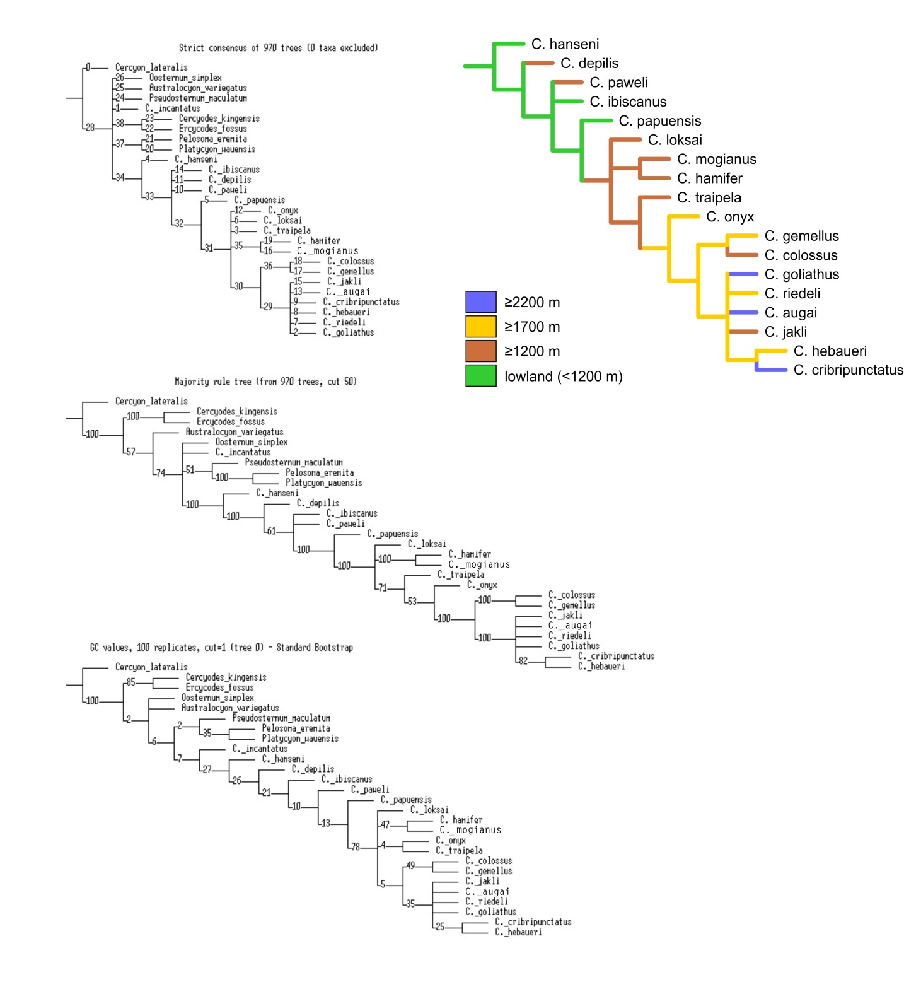
Supplementary Figure S1. Result of the maximum parsimony analysis of morphological data (top: strict consensus tree, middle: majority rule consensus, bottom: bootstrap tree) and altitudinal distribution mapped on the majority consensus tree.

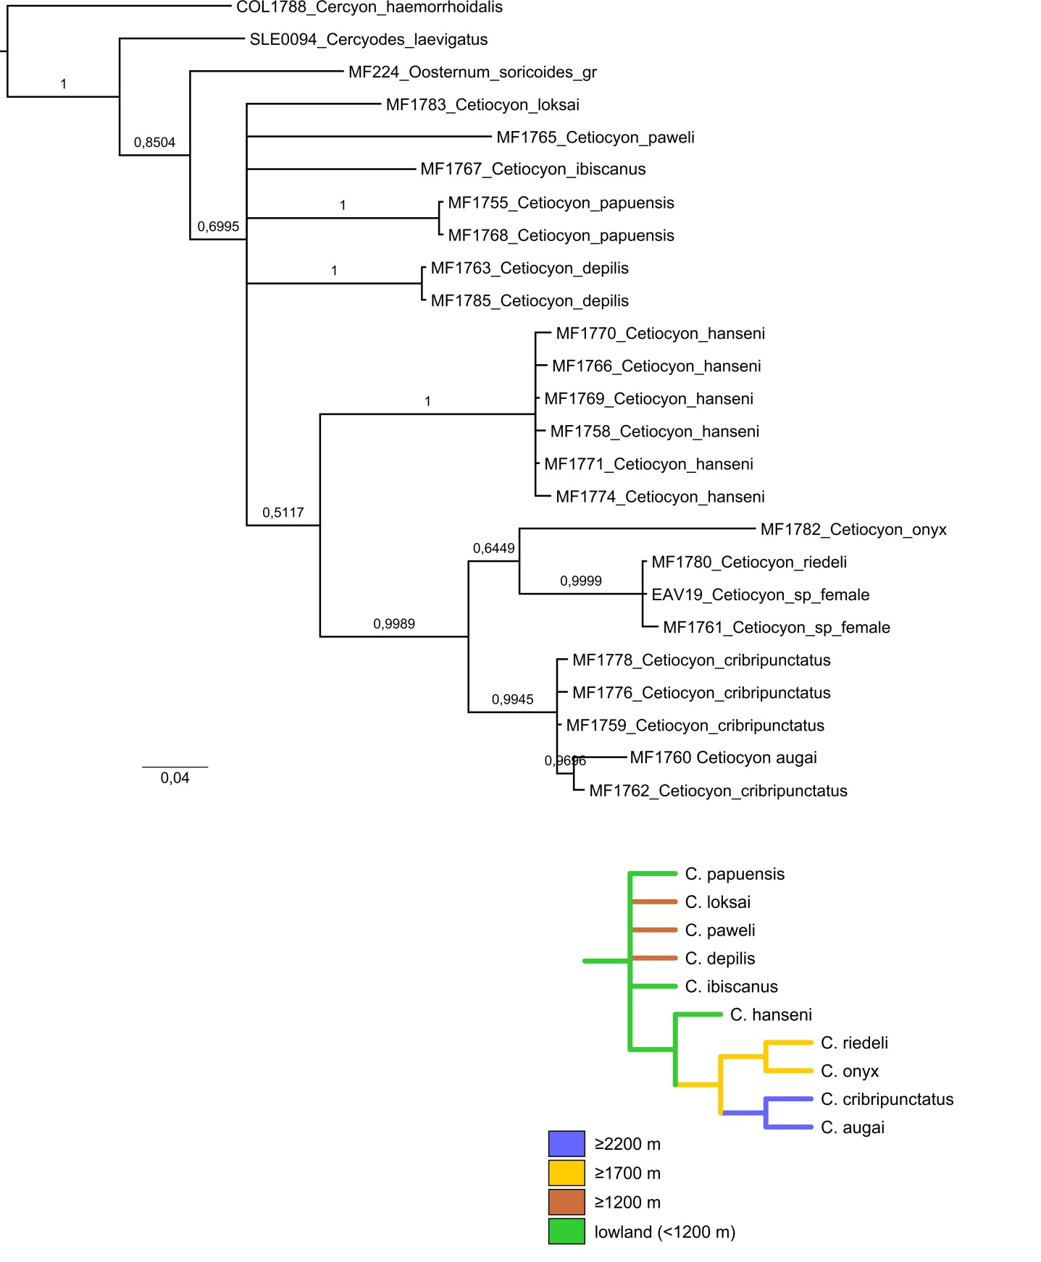
Supplementary Figure S2. Result of the Bayesian phylogenetic analysis of cox1 data and altitudinal distribution mapped on the tree.

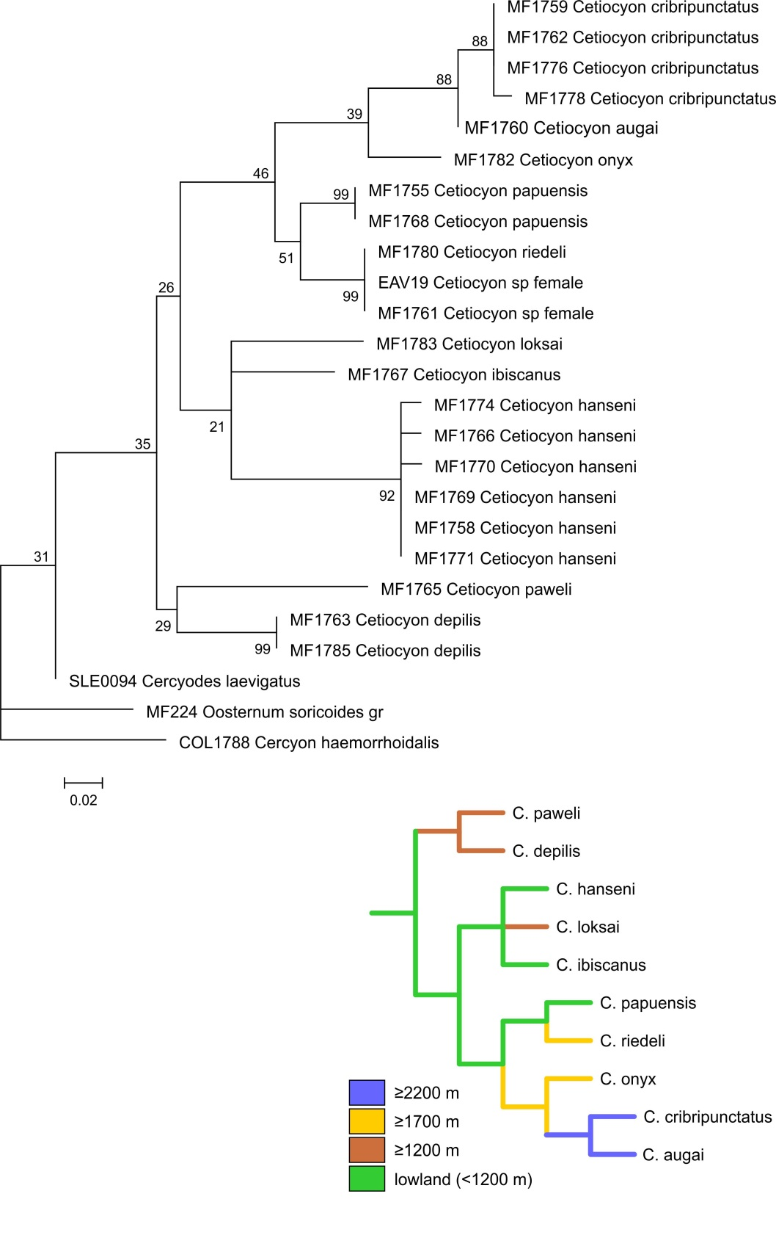

Supplementary Figure S3. Result of the maximum likelihood phylogenetic analysis of cox1 data and altitudinal distribution mapped on the tree.

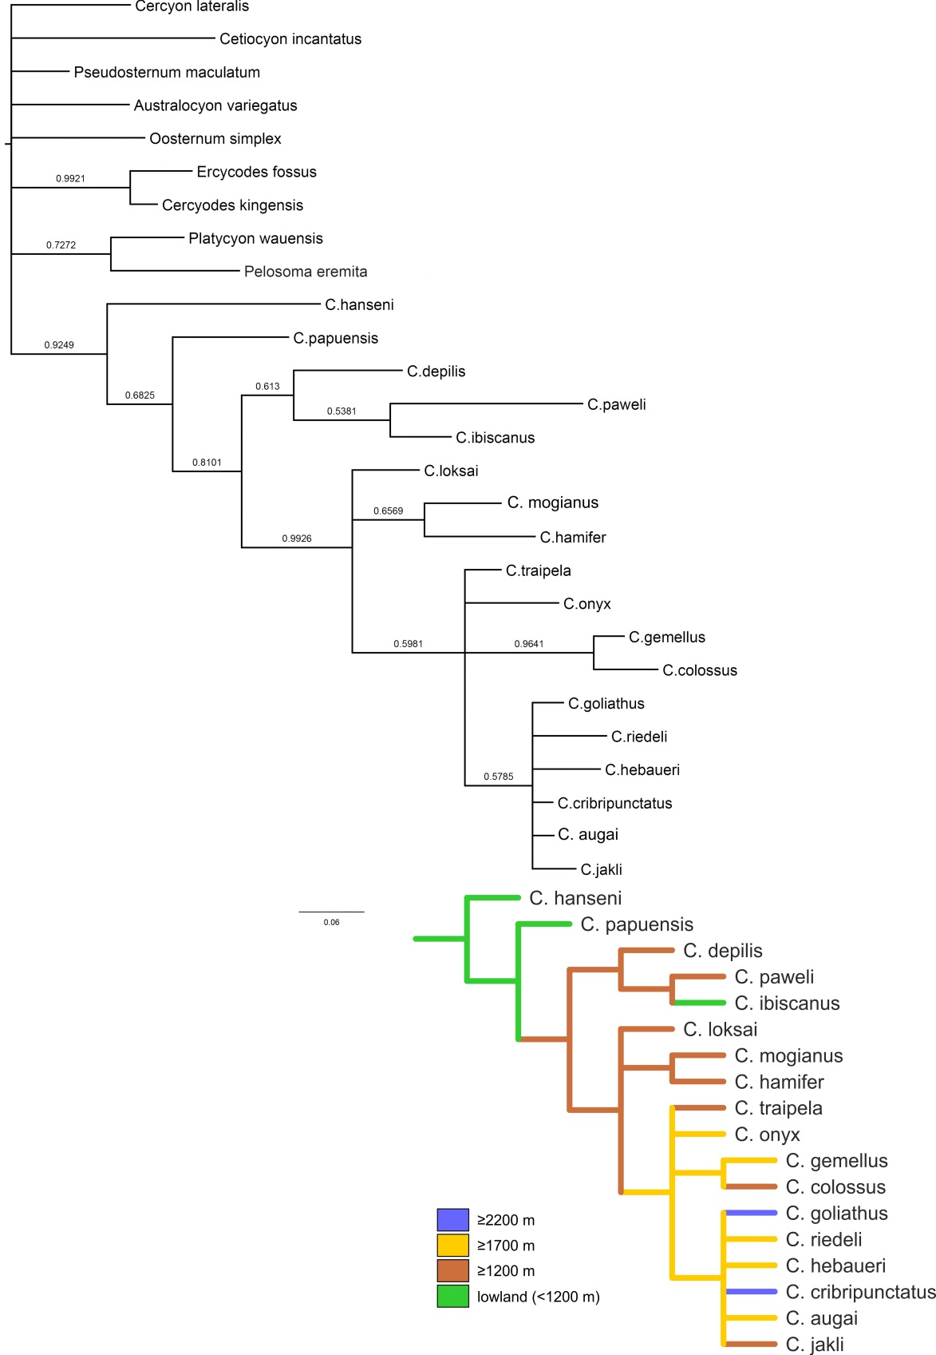

Supplementary Figure S4. Result of the Bayesian phylogenetic analysis of combined cox1 and morphological data, data and altitudinal distribution mapped on the tree.

