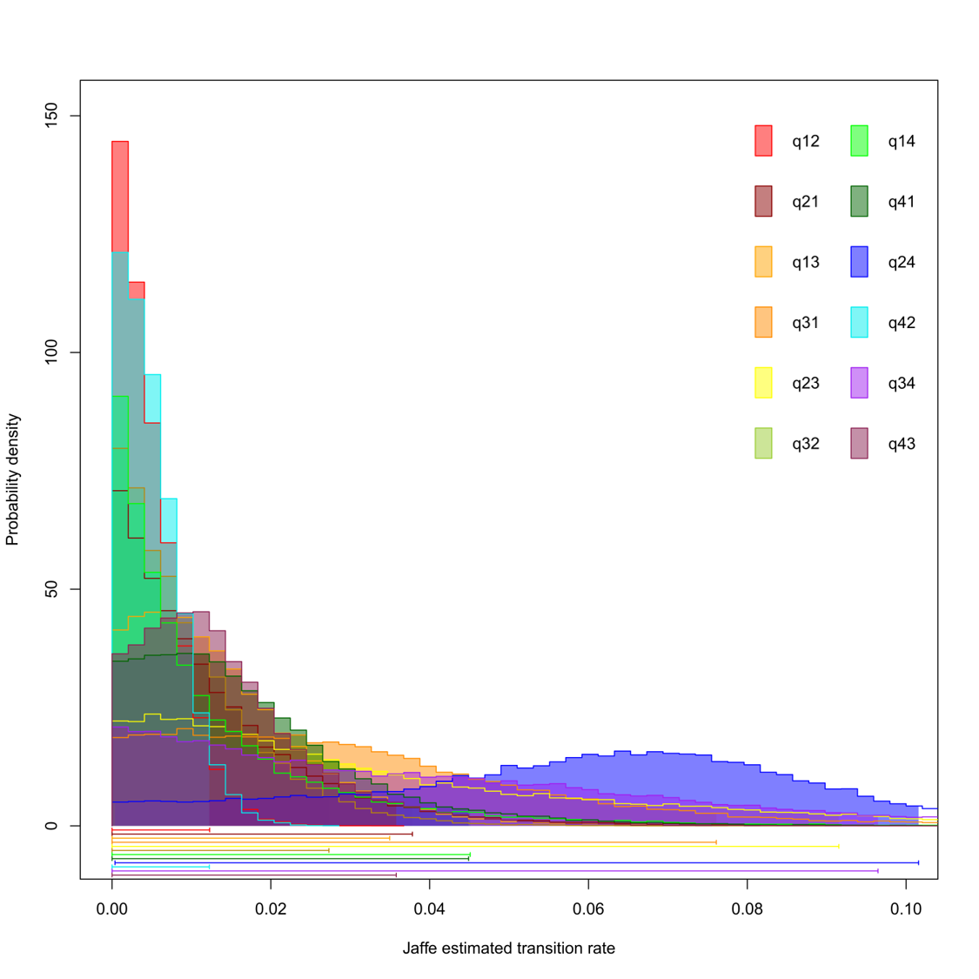
Fig. S1. Transition rates for an ARD model. A transition from tandem running to chemical mass recruitment has a notably higher rate than any other transitions. Transitions between solitary and tandem running, and chemical mass recruitment and tandem running, are close to 0. Numbers: 1=Solitary foraging, 2=tandem running, 3=group recruitment, 4=chemical mass recruitment.
Fig. S2. Transition rates for a SYM model. Half of transition rates are close to 0; transitions between solitary and recruitment foraging, and recruitment and trunk trails have notably higher rates than other transitions. The high spread for the transition between solitary and trunk trails is likely due to these rates not actually being symmetrical. Numbers: 1=Solitary foraging, 2=recruitment, 3=group hunting, 4=trunk trails.
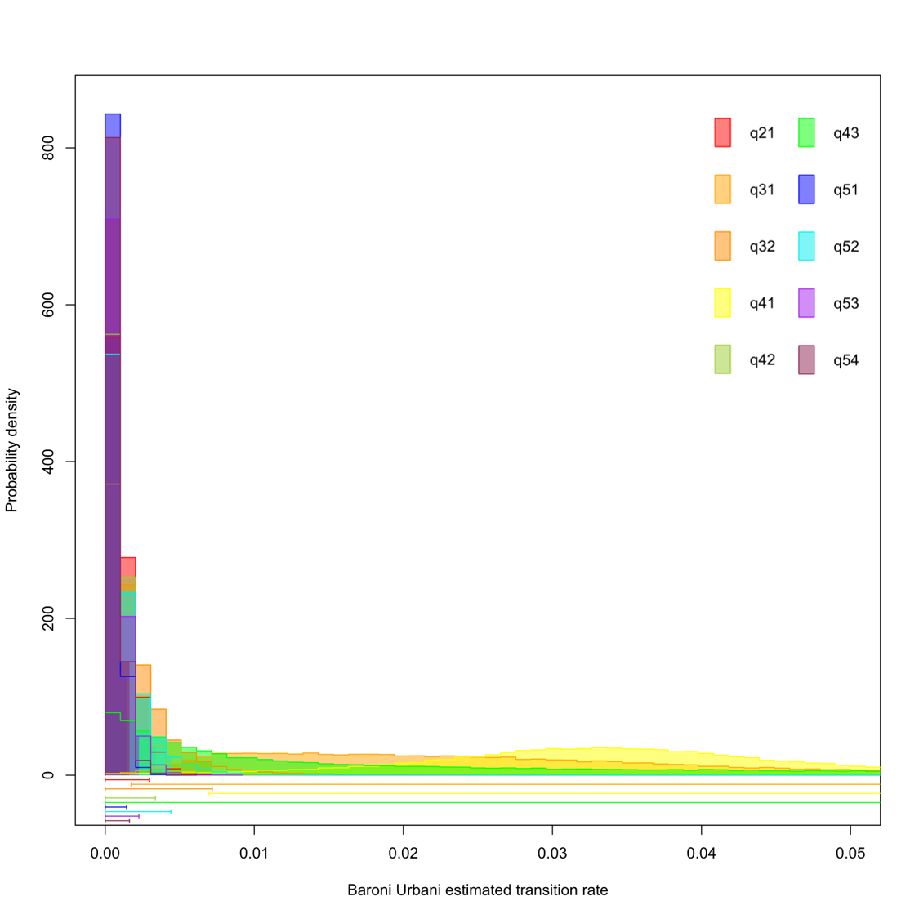
Fig. S3. Transition rates for a SYM model. Transitions between solitary foraging and group hunting, and between solitary foraging and chemical mass recruitment, occur at a higher rate than others; however, high spread is likely due to these rates not being truly symmetrical. Low probability density is likely due to the high number of parameters. Numbers: 1=Solitary foraging, 2=group recruitment, 3=chemical mass recruitment, 4=group hunting.
Fig. S4. Transition rates from an ARD model. A transition from solitary foraging to chemical mass recruitment has a notably higher rate than any other transitions. Transitions from chemical mass recruitment to group recruitment, chemical mass recruitment to solitary foraging, and group recruitment to solitary foraging have non-zero rates. Numbers: 1=Solitary foraging, 2=group recruitment, 3=chemical mass recruitment.
Fig. S5. Speciation rates from an ARD model. Lambda 1 = solitary; lambda 2 = tandem running; lambda 3 = group recruitment; lambda 4 = chemical mass recruitment.
Fig. S6. Speciation rates from a SYM model. Lambda 1 = solitary; lambda 2 = recruitment; lambda 3 = group hunting; lambda 4 = trunk trails.
Fig. S7. Speciation rates from a SYM model. Lambda 1 = solitary; lambda 2 = tandem running; lambda 3 = group recruitment; lambda 4 = chemical mass recruitment, lambda 5 = group hunting.
Fig. S8. Speciation rates from an ARD model. Lambda 1 = solitary; lambda 2 = group recruitment; lambda 3 = chemical mass recruitment.

